LAB 4

(a). Pseudo code to implement spanning tree in SDN network:

Step 1: Let Spanning Tree ST be an empty set

Step 2: For every vertex v of Graph G, we make an empty set of v Step 3: We then sort the (u,v) edges of G in ascending order

Step 4: For each edge (u, v) from the sorted list we get in the previous Step 3 If u and v belong to different sets

Add (u,v) to T

Get together u and v in one single set Step 5: Return T

def _calculate_spanning_tree ():

"""
Calculates the actual spanning tree

Returns it as dictionary where the keys are DPID1, and the values are tuples of (DPID2, port-‐num), where port-‐num is the port on DPID1 connecting to DPID2.

"""
def flip (link):

return Discovery.Link(link[2],link[3], link[0],link[1])

adj = defaultdict(lambda:defaultdict(lambda:[])) switches = set()
# Add all links and switches
for l in core.openflow_discovery.adjacency: adj[l.dpid1][l.dpid2].append(l) switches.add(l.dpid1) switches.add(l.dpid2)

# Cull links -‐-‐ we want a single symmetric link connecting nodes for s1 in switches:

for s2 in switches:

if s2 not in adj[s1]: continue

if not isinstance(adj[s1][s2], list): continue

assert s1 is not s2 good = False

for l in adj[s1][s2]:
if flip(l) in core.openflow_discovery.adjacency:

# This is a good one adj[s1][s2] = l.port1 adj[s2][s1] = l.port2 good = True

Break

if not good: del adj[s1][s2] if s1 in adj[s2]:

# Delete the other way too del adj[s2][s1]

Reference: https://github.com/att/pox/blob/master/pox/openflow/spanning_tree.py

(b). Advantages of using OpenVSwitch and SDN controller compared to IP networks

- It provides a centralized view of the network: Central Controller

- Global enterprise management: SDN controllers that maintain a global view of the network, which appears to applications and policy engines as a single, logical switch

- Directly Programmable: Network control is directly programmable because it is decoupled from forwarding functions i.e. Data plane is separated from Control plane

- Reduce complexity through automation / Agile: Abstracting control from forwarding lets administrators dynamically adjust network-‐wide traffic flow to meet changing needs. OpenFlow-‐ based SDN thus offers a flexible network automation and management framework, which makes it possible to develop tools that automate many management tasks that are done manually today

- And thus one can achieve centralized security: SDN makes it possible for IT to define high-‐level configuration and policy statements, which are then translated down to the infrastructure via OpenFlow. An OpenFlow-‐based SDN architecture eliminates the need to individually configure network devices each time an end point, service, or application is added or moved, or a policy changes, which reduces the likelihood of network failures due to configuration or policy inconsistencies.

- Simplified Network design: SDN simplifies network design and operation because instructions are provided by SDN controllers instead of multiple, vendor-‐specific devices and protocols.

- Operating costs are lower as compared to traditional IP networks

- Hardware savings

- Reduced capital expenditures

- Cloud abstraction is possible

(c). Controller’s Code

from ryu.base import app_manager from ryu.controller import ofp_event

from ryu.controller.handler import CONFIG_DISPATCHER, MAIN_DISPATCHER

from ryu.controller.handler import set_ev_cls from ryu.ofproto import ofproto_v1_3

from ryu.ofproto import ether from ryu.ofproto import inet from ryu.lib.packet import packet from ryu.lib.packet import ethernet from ryu.lib.packet import arp from ryu.lib.packet import ipv4 from ryu.lib.packet import tcp from ryu.lib.packet import udp

# you may import more libs here, but the above libs should be enough

class SimpleSwitch13(app_manager.RyuApp): OFP_VERSIONS = [ofproto_v1_3.OFP_VERSION]

def __init__(self, *args, **kwargs): super(SimpleSwitch13, self).__init__(*args, **kwargs)
- arp table: for searching self.arp_table={}

- fill in the table for arp searching

self.arp_table["10.0.0.1"] = "00:00:00:00:00:01" self.arp_table["10.0.0.2"] = "00:00:00:00:00:02" self.arp_table["10.0.0.3"] = "00:00:00:00:00:03" self.arp_table["10.0.0.4"] = "00:00:00:00:00:04"

"""

Hand-‐shake event call back method
This is the very initial method where the switch hand shake with the controller

It checks whether both are using the same protocol version: OpenFlow 1.3 in this case

Therefore in this method, you can setup some static rules. e.g. the rules which sends unknown packets to the controller
the rules directing TCP/UDP/ICMP traffic ACL rules

"""
@set_ev_cls(ofp_event.EventOFPSwitchFeatures, CONFIG_DISPATCHER) def switch_features_handler(self, ev):

datapath = ev.msg.datapath ofproto = datapath.ofproto parser = datapath.ofproto_parser

# Insert Static rule

match = parser.OFPMatch()

actions = [parser.OFPActionOutput(ofproto.OFPP_CONTROLLER, ofproto.OFPCML_NO_BUFFER)]

self.add_flow(datapath, 0, match, actions)

# Installing static rules to process TCP/UDP and ICMP and ACL dpid = datapath.id # classifying the switch ID

if dpid == 3:
self.add_layer4_rules(datapath, inet.IPPROTO_TCP, '10.0.0.1', 10, 1) # change self.add_layer4_rules(datapath, inet.IPPROTO_TCP, '10.0.0.3', 10, 2) # change self.add_layer4_rules(datapath, inet.IPPROTO_TCP, '10.0.0.2', 10, 3) # change self.add_layer4_rules(datapath, inet.IPPROTO_TCP, '10.0.0.4', 10, 3) # change

self.add_layer4_rules(datapath, inet.IPPROTO_ICMP, '10.0.0.1', 10, 1) # change self.add_layer4_rules(datapath, inet.IPPROTO_ICMP, '10.0.0.3', 10, 2) # change self.add_layer4_rules(datapath, inet.IPPROTO_ICMP, '10.0.0.2', 10, 3) # change self.add_layer4_rules(datapath, inet.IPPROTO_ICMP, '10.0.0.4', 10, 3) # change

self.add_layer4_rules(datapath, inet.IPPROTO_UDP, '10.0.0.1', 10, 1) # change self.add_layer4_rules(datapath, inet.IPPROTO_UDP, '10.0.0.3', 10, 2) # change self.add_layer4_rules(datapath, inet.IPPROTO_UDP, '10.0.0.2', 10, 4) # change self.add_layer4_rules(datapath, inet.IPPROTO_UDP, '10.0.0.4', 10, 4) # change

- implement ACL rules

- this rule directs the TCP packets from h1 to h3 to the controller match = parser.OFPMatch(eth_type = ether.ETH_TYPE_IP,
ipv4_src = '10.0.0.1', ipv4_dst = '10.0.0.3', ip_proto = inet.IPPROTO_TCP)

actions = [parser.OFPActionOutput(ofproto.OFPP_CONTROLLER, ofproto.OFPCML_NO_BUFFER)]

self.add_flow(datapath, 30, match, actions)

elif dpid == 4:

self.add_layer4_rules(datapath, inet.IPPROTO_TCP, '10.0.0.2', 10, 1) # change self.add_layer4_rules(datapath, inet.IPPROTO_TCP, '10.0.0.4', 10, 2) # change self.add_layer4_rules(datapath, inet.IPPROTO_TCP, '10.0.0.1', 10, 3) # change self.add_layer4_rules(datapath, inet.IPPROTO_TCP, '10.0.0.3', 10, 3) # change

self.add_layer4_rules(datapath, inet.IPPROTO_ICMP, '10.0.0.2', 10, 1) # change self.add_layer4_rules(datapath, inet.IPPROTO_ICMP, '10.0.0.4', 10, 2) # change self.add_layer4_rules(datapath, inet.IPPROTO_ICMP, '10.0.0.1', 10, 3) # change self.add_layer4_rules(datapath, inet.IPPROTO_ICMP, '10.0.0.3', 10, 3) # change

self.add_layer4_rules(datapath, inet.IPPROTO_UDP, '10.0.0.2', 10, 1) # change self.add_layer4_rules(datapath, inet.IPPROTO_UDP, '10.0.0.4', 10, 2) # change self.add_layer4_rules(datapath, inet.IPPROTO_UDP, '10.0.0.1', 10, 4) # change self.add_layer4_rules(datapath, inet.IPPROTO_UDP, '10.0.0.3', 10, 4) # change

elif dpid == 5:

# fwding everthing between port 1 and port 2 actions = [parser.OFPActionOutput(2)] match = parser.OFPMatch(in_port = 1,

eth_type = ether.ETH_TYPE_IP) self.add_flow(datapath, 10, match, actions) actions = [parser.OFPActionOutput(1)] match = parser.OFPMatch(in_port = 2,

eth_type = ether.ETH_TYPE_IP) self.add_flow(datapath, 10, match, actions)

match = parser.OFPMatch(eth_type = ether.ETH_TYPE_IP, ipv4_src = '10.0.0.2',

ipv4_dst = '10.0.0.3',
ip_proto = inet.IPPROTO_UDP)

actions = []
self.add_flow(datapath, 30, match, actions)

else:

print "wrong switch"

"""

Call back method for PacketIn Message
This is the call back method when a PacketIn Msg is sent from a switch to the controller

It handles L3 classification in this function:
"""

@set_ev_cls(ofp_event.EventOFPPacketIn, MAIN_DISPATCHER) def _packet_in_handler(self, ev):

msg = ev.msg
datapath = msg.datapath ofproto = datapath.ofproto parser = datapath.ofproto_parser

in_port = msg.match['in_port'] pkt = packet.Packet(msg.data)
eth = pkt.get_protocol(ethernet.ethernet)

ethertype = eth.ethertype

# process ARP

if ethertype == ether.ETH_TYPE_ARP: self.handle_arp(datapath, in_port, pkt) return

# process IP

if ethertype == ether.ETH_TYPE_IP: self.handle_ip(datapath, in_port, pkt) return

# Member methods you can call to install TCP/UDP/ICMP fwding rules

def add_layer4_rules(self, datapath, ip_proto, ipv4_dst = None, priority = 1, fwd_port = None):

parser = datapath.ofproto_parser
actions = [parser.OFPActionOutput(fwd_port)]

match = parser.OFPMatch(eth_type = ether.ETH_TYPE_IP, ip_proto = ip_proto,

ipv4_dst = ipv4_dst) self.add_flow(datapath, priority, match, actions)

# Member methods you can call to install general rules def add_flow(self, datapath, priority, match, actions):
ofproto = datapath.ofproto parser = datapath.ofproto_parser

inst = [parser.OFPInstructionActions(ofproto.OFPIT_APPLY_ACTIONS, actions)]

mod = parser.OFPFlowMod(datapath=datapath, priority=priority, match=match, instructions=inst)

datapath.send_msg(mod)

"""

Methods to handle ARP. In this implementation the controller generates the ARP reply msg back to the host who initiate it. So the controller should parse out the ARP request;

Search the ARP table for correponding dst MAC; Generate ARP reply;

And finally use PacketOut Message to send back the ARP reply
"""

def handle_arp(self, datapath, in_port, pkt):

ofproto = datapath.ofproto parser = datapath.ofproto_parser

# parse out the ethernet and arp packet eth_pkt = pkt.get_protocol(ethernet.ethernet) arp_pkt = pkt.get_protocol(arp.arp)

# obtain the MAC of dst IP
arp_resolv_mac = self.arp_table[arp_pkt.dst_ip]

ether_hd = ethernet.ethernet(dst = eth_pkt.src, src = arp_resolv_mac,
ethertype = ether.ETH_TYPE_ARP);

arp_hd = arp.arp(hwtype = 1, proto = 0x0800, hlen = 6, plen = 4, opcode = 2, src_mac = arp_resolv_mac, src_ip = arp_pkt.dst_ip, dst_mac = eth_pkt.src, dst_ip = arp_pkt.src_ip)

arp_reply = packet.Packet(); arp_reply.add_protocol(ether_hd) arp_reply.add_protocol(arp_hd) arp_reply.serialize()

# send the Packet Out mst to back to the host who is initilaizing the ARP actions = [parser.OFPActionOutput(in_port)];

out = parser.OFPPacketOut(datapath, ofproto.OFP_NO_BUFFER, ofproto.OFPP_CONTROLLER, actions, arp_reply.data)

datapath.send_msg(out)

"""

Methods to handle TCP/IP. In this implementation the controller generate the TCP RST for connections between h1 and h3.

In switch_features_handler() you should put a static rule to fwd those packets to the controller, and in handle_ip() you need to generate and return the TCP RST with PacketOut Message

"""
def handle_ip(self, datapath, in_port, pkt): ofproto = datapath.ofproto

parser = datapath.ofproto_parser

ipv4_pkt = pkt.get_protocol(ipv4.ipv4) # parse out the IPv4 pkt

if datapath.id == 3 and ipv4_pkt.proto == inet.IPPROTO_TCP: tcp_pkt = pkt.get_protocol(tcp.tcp) # parser out the TCP pkt

- generate the TCP packet with the RST flag set to 1
- packet generation is similar to ARP,

- but you need to generate ethernet-‐>ip-‐>tcp and serialize it

ether_frame = ethernet.ethernet(dst = self.arp_table[ipv4_pkt.src], src = self.arp_table[ipv4_pkt.dst],
ethertype = ether.ETH_TYPE_IP)
ip_packet = ipv4.ipv4(version = 4, header_length = 5, tos = 0, total_length = 0, identification = 0, flags = 0,

offset = 0, ttl = 255, proto = 0x06, csum = 0,
src = ipv4_pkt.dst, dst = ipv4_pkt.src, option = None)

tcp_segment = tcp.tcp(src_port = tcp_pkt.dst_port, dst_port = tcp_pkt.src_port, seq = 0, ack = (tcp_pkt.seq + 1), offset = 0, bits = 0x004, window_size = 0, csum = 0, urgent = 0, option = None)

tcp_rst_ack = packet.Packet(); tcp_rst_ack.add_protocol(ether_frame) tcp_rst_ack.add_protocol(ip_packet) tcp_rst_ack.add_protocol(tcp_segment) tcp_rst_ack.serialize()

- send the Packet Out mst to back to the host who is initilaizing the ARP actions = [parser.OFPActionOutput(in_port)];

out = parser.OFPPacketOut(datapath, ofproto.OFP_NO_BUFFER, ofproto.OFPP_CONTROLLER, actions, tcp_rst_ack.data)

datapath.send_msg(out)

(d). Topology.py

- import the topology creater class in Mininet from mininet.topo import Topo

- create the class for creation of custom topology class Lab4(Topo):

  - define constructor

def __init__(self):
- call super class constructor Topo.__init__(self)
- add nodes

host1 = self.addHost('H1') host2 = self.addHost('H2') host3 = self.addHost('H3') host4 = self.addHost('H4') switchC = self.addSwitch('S3')

switchD = self.addSwitch('S4') switchE = self.addSwitch('S5')
# add links
self.addLink(host1, switchC, port2 = 1) self.addLink(host3, switchC, port2 = 2) self.addLink(host2, switchD, port2 = 1) self.addLink(host4, switchD, port2 = 2) self.addLink(switchC, switchD, port1 = 3, port2 = 3) self.addLink(switchC, switchE, port1 = 4, port2 = 1) self.addLink(switchD, switchE, port1 = 4, port2 = 2)

topos = {'Lab4' : (lambda : Lab4())}

Screenshot of command used for executing the topology and controller
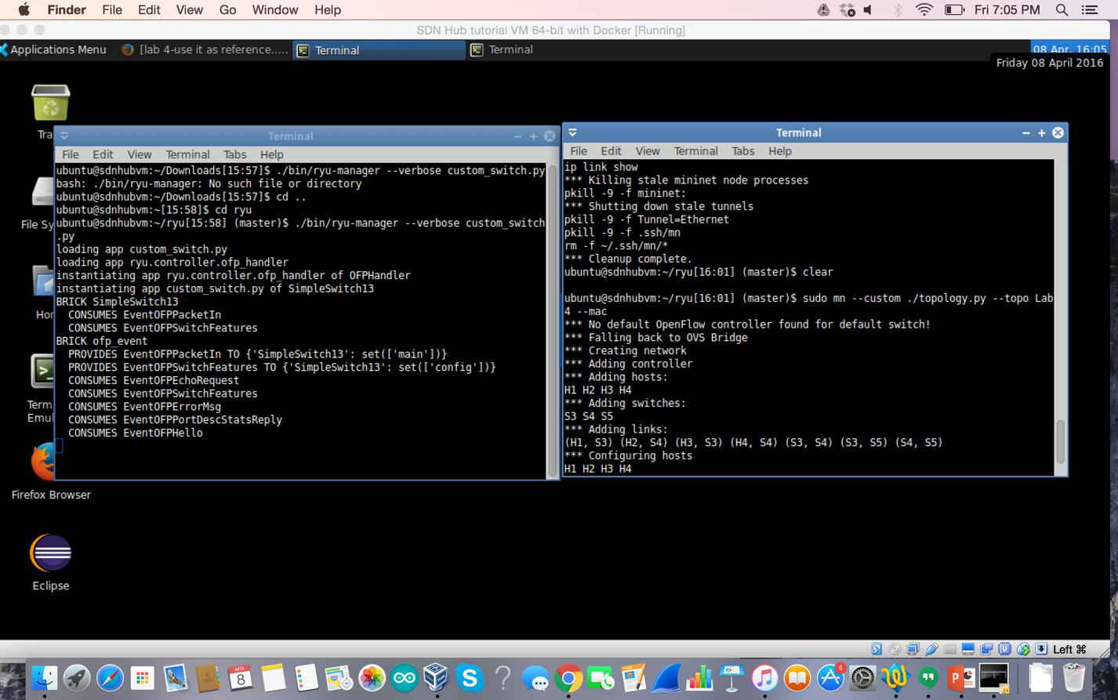

Screenshot for testing connectivity pingall
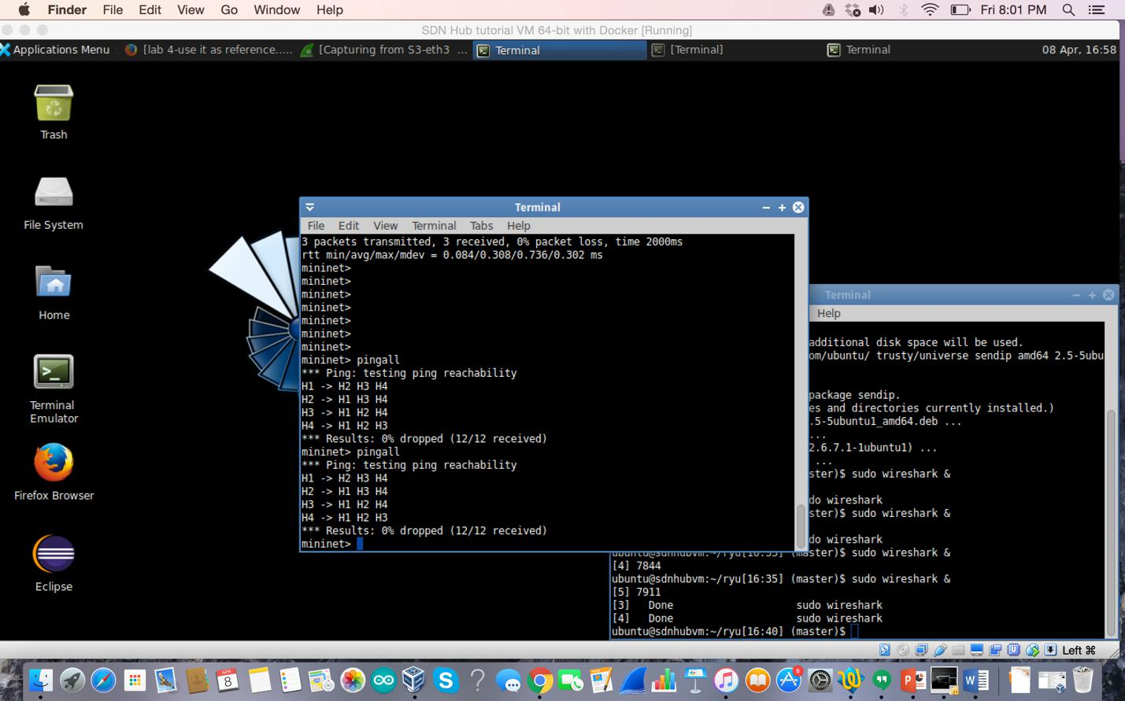

Implementation of rules on all the switches(S3, S4,S5)
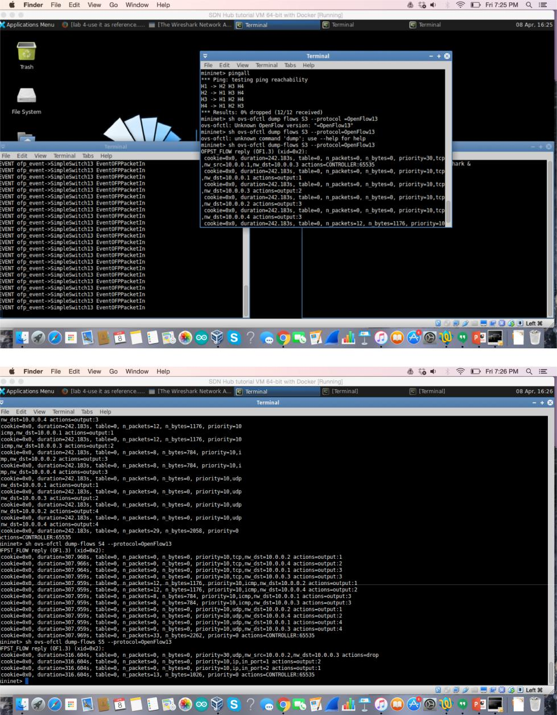

Screenshot for capturing TCP packets
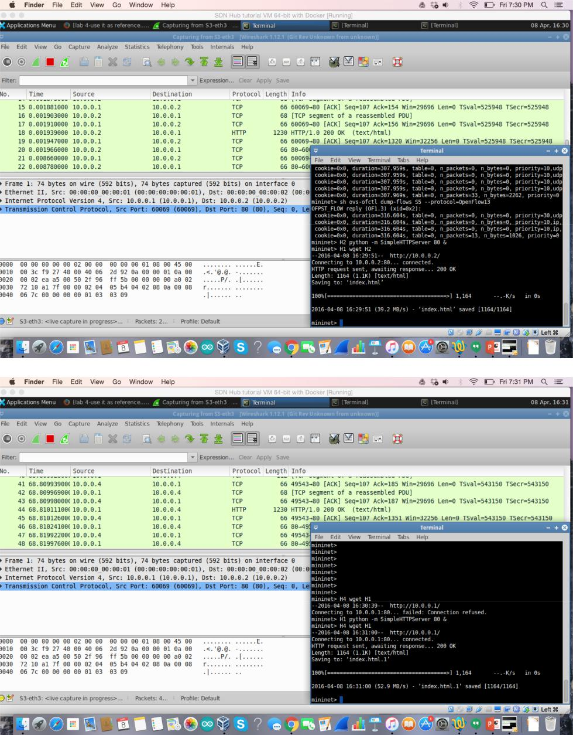

Screenshot for UDP packets
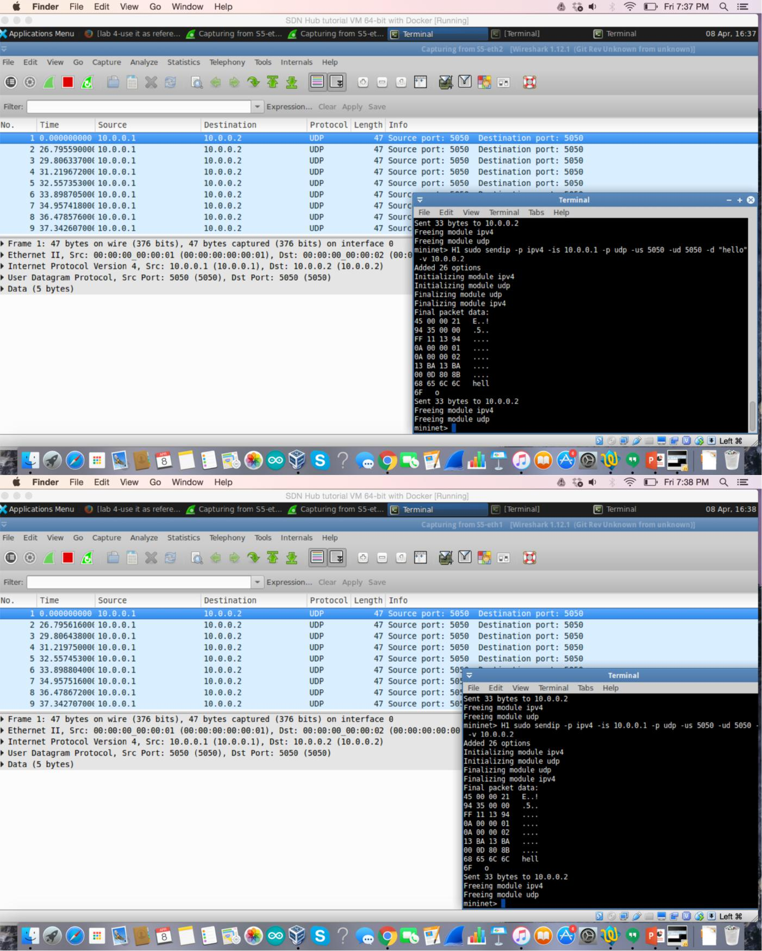
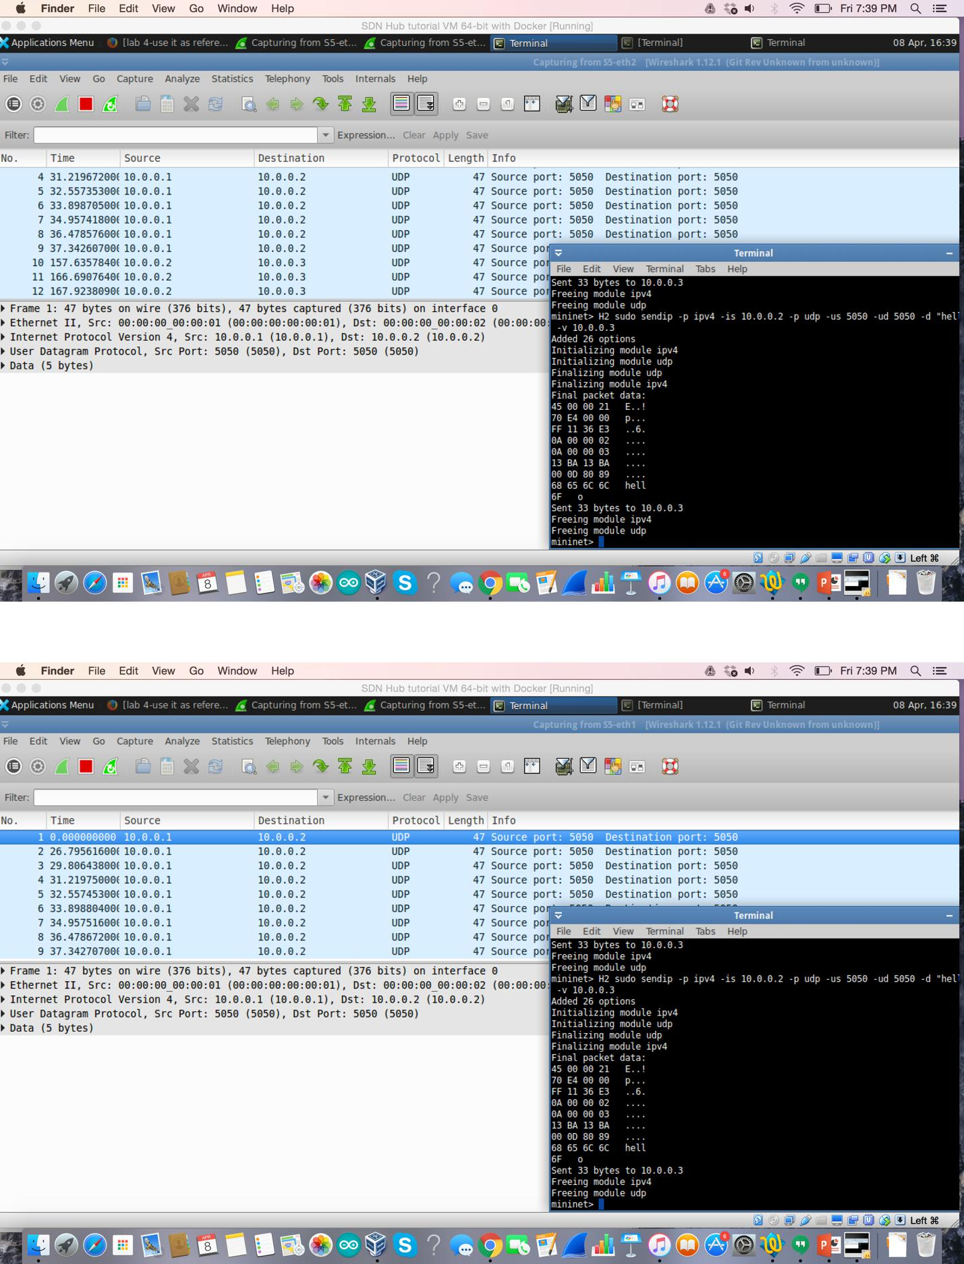

Screenshots for ICMP packets
